Macroeconomics Final report

Team 5

21600627 Jeon Haram

21600685 Cho ye seong

21700604 Lee hyeji

21800445 Oh eun Hye

I. Introduction

As the world enters a period of low growth and low prices, each major country is implanting a policy of lowering interest rates by as little as 0 percent. Some countries are even looking to take the “unprecedented path” of negative interest rates. Korea’s economic situation, which has been heavily dependent on exports to China and Japan due to the trade war between the G2 world America and China, has entered a more unpredictable phase. Currently, the Bank of Korea is watching the economy with two rate cuts in July and October this year, but there is no special effect on it yet. In the case of Korea’s current economic situation, even though household debt’s change rate is decreased, it is still increased and due to various factors affecting low growth, including a drop in exports and a outflow of foreign capital due to interest rate differences with the United States, the country is growing at 2 percent, far below the current target of 2 percent, while inflation remains at 0.4 percent. Therefore, we wanted to observe the domestic consumption and price trends, the current account and real estate markets, and the current situation of bonds and lending rates, as well as external factors such as the U.S – China trade war, which do not have any special effect on the two base rate cuts, and to explore the direction of how the Bank of Korea will adjust its base interest rate.

II. World Economic trends

There’s a variety of events happening all over the world today. These events are driving the trend of the world economy. We want to bring these four events : The U.S – China trade war, the Hong Kong protests, the Japanese export regulation, and the Brexit, to see the trends of the world economy and explain the impact of the trends on our economy.

1. The U.S – China trade war

As the trade between the U.S. and China intensifies, Korea’s exports will suffer greatly. The United States and China account for 38.1 percent of our exports. Therefore, if the trade war continues, it will affect the macroeconomics such as investment delay, financial market instability, exchange rate, and oil price. This effect will affect our interest rates. The International Monetary Fund also warned that Korea is the most vulnerable country in the wake of the U.S. – China trade war. China’s exports to the U.S. decrease when tariffs rise, in line with the fact that Korea’s exports to China, mainly in the fields of semiconductors and electricity and electronics, are directly affected. In its April 2019 World Economic Outlook report, the IMF estimated that a 1 percentage point increase in global tariff rates would reduce Korea’s GDP by 0.65 percent.

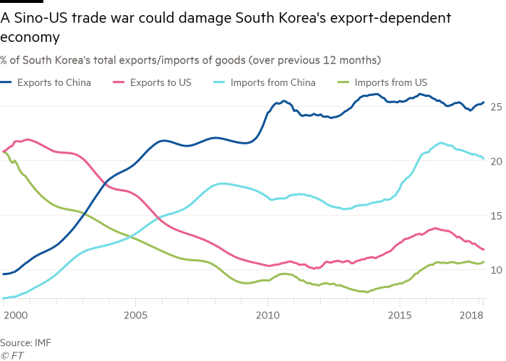

*Source :* [*https://www.mk.co.kr/news/economy/view/2019/04/207115/*](https://www.mk.co.kr/news/economy/view/2019/04/207115/)

*Source:* <https://www.ft.com/content/374e899e-8592-11e8-96dd-fa565ec55929>

1. The Hong Kong protests

If Hong Kong’s real estate prices fall and Hong Kong’s economy hits the market, the Korean Economy is also feared to be hit. Many of Korea’s exports to Hong Kong are re-exported to China. As a result, there is speculation that if the Hong Kong crisis intensifies, exports to China, which is already shrinking in the aftermath of the U.S.-China trade dispute, will be further reduced. Exports of semiconductors(MTI831110) to China and Hong Kong decreased 30.4% and 37.2% respectively in 2019.

< Current status of memory semiconductor exports and imports >

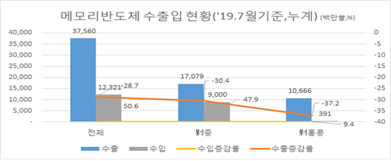

*Source :*

[*https://news.kotra.or.kr/user/globalBbs/kotranews/3/globalBbsDataView.do?setIdx=242&dataIdx=176941*](https://news.kotra.or.kr/user/globalBbs/kotranews/3/globalBbsDataView.do?setIdx=242&dataIdx=176941)

1. The Japanese export Regulation

Korea’s financial markets will be hit by Japan’s regulation of some items exported to Korea. There is no immediate impact, but there are predictions that a prolonged or aggravated conflict will have a negative impact on Korea, including a bigger loss in GDP than on Japan. Japan’s export regulations forecast an average 2.8 percent drop in sales for the domestic corporations. By industry, first of all, general machinery(-13.6%), and petroleum products(-7.0%), semiconductors(-6.6%, steel products(-3.9%) and then wireless communication devices(-2.7%) would be hit in this order.

< Impact of operating profit by industry according to export regulations in Japan > 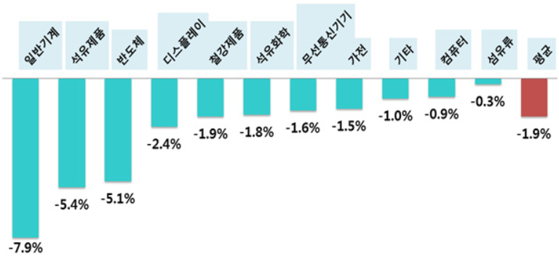 *Source :*

[*https://www.hankookilbo.com/News/Read/201908191298311822*](https://www.hankookilbo.com/News/Read/201908191298311822)

1. Brexit

External uncertainties in the EU economy, which accounts for about one-third of the world’s fifth-largest economy and global GDP, are expected to have a significant impact on the Korean economy, which is an export-driven small opening economy. The Korea Economic Research Institute (KERI) released a report predicting the ripple effects of each country when implementing ‘No deal Brexit’, which shows that No deal Brexit in the U.K. will continue to affect Korea’s real GDP in the long run. The report suggests that Korea may see a 0.1 percent increase in real GDP in the short term, but the biggest decline in the long term could be made in the long run.( a cumulative 3.1 percent decrease by 2033)

< Estimate long-term Real GDP effects of No deal Brexit >

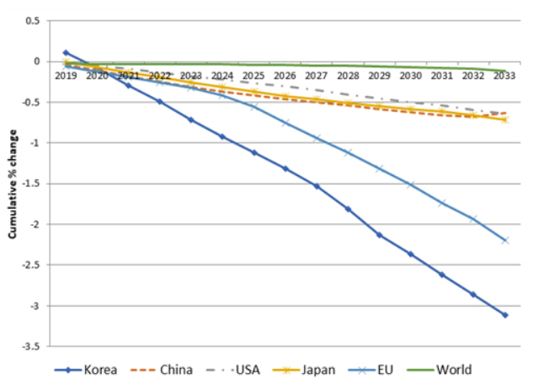

*Source :*

[*http://www.keri.org/web/www/research_0201?p_p_id=EXT_BBS&p_p_lifecycle=0&p_p_state=normal&p_p_mode=view&p_p_col_id=column-1&p_p_col_count=1&_EXT_BBS_struts_action=%2Fext%2Fbbs%2Fview_message&_EXT_BBS_sCategory=&_EXT_BBS_sKeyType=&_EXT_BBS_sKeyword=&_EXT_BBS_curPage=1&_EXT_BBS_optKeyType1=&_EXT_BBS_optKeyType2=&_EXT_BBS_optKeyword1=&_EXT_BBS_optKeyword2=&_EXT_BBS_sLayoutId=0&_EXT_BBS_messageId=355751*](http://www.keri.org/web/www/research_0201?p_p_id=EXT_BBS&p_p_lifecycle=0&p_p_state=normal&p_p_mode=view&p_p_col_id=column-1&p_p_col_count=1&_EXT_BBS_struts_action=%2Fext%2Fbbs%2Fview_message&_EXT_BBS_sCategory=&_EXT_BBS_sKeyType=&_EXT_BBS_sKeyword=&_EXT_BBS_curPage=1&_EXT_BBS_optKeyType1=&_EXT_BBS_optKeyType2=&_EXT_BBS_optKeyword1=&_EXT_BBS_optKeyword2=&_EXT_BBS_sLayoutId=0&_EXT_BBS_messageId=355751)

As such, the global economic trend is an external factor affecting the Korean economy. As of December 2019, one of the factors affecting Korea’s interest rates is the international situation. The fact that the international situation affects Korea’s economic state means that it also affects Korea’s interest rates. Therefore, Korean interest rates can go up or down depending on the global economic trends caused by the international situation.

III. Analysis of the real economy in Korea

1. Consumption and Production

The consumption trend index is representative of the consumption trend. And we can check the consumption trends of our people through the retail sales price index. Also, consumption trends in Korea can be seen through GNI(Gross National Income)/GDI(Gross Domestic Income).

The consumer trend index is based on 100. Higher than 100 is an optimistic forecast that people will spend more, and lower than 100 is a pessimistic prediction that people will not spend more. People spend less money on clothes and leisure as the economy gets worse. According to the table below, people now tend to spend less on leisure. This means that the economy is not booming. The overall consumer spending outlook, however, is not extremely pessimistic. So maintaining a current rate freeze is not a bad option.

< Consumer Trend Index from 2018.1 to 2019. 11 >

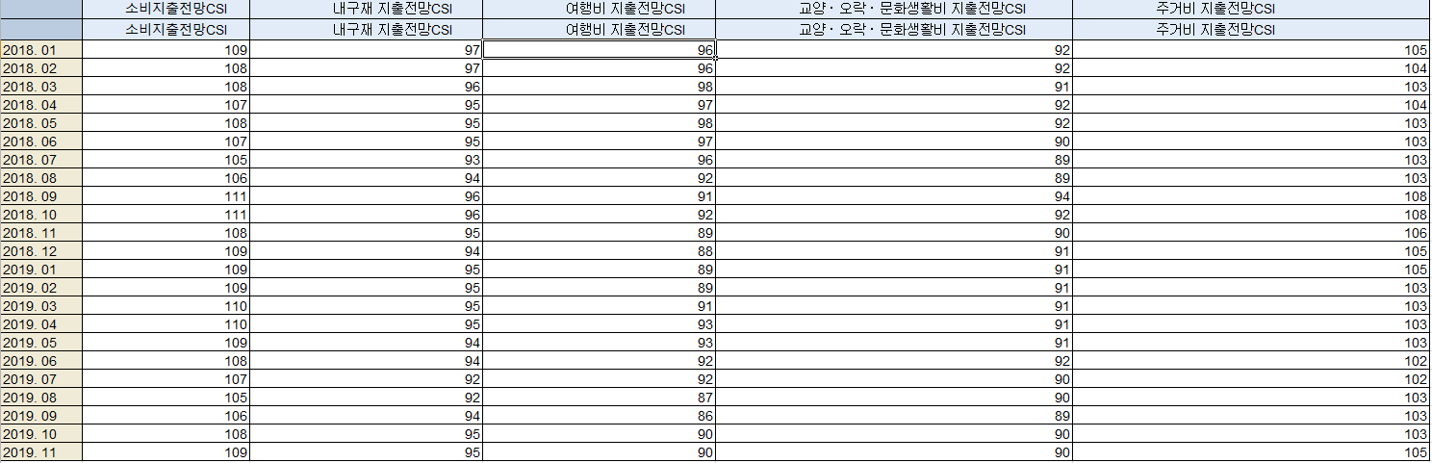

*Source : Bank of Korea :* [*http://ecos.bok.or.kr/*](http://ecos.bok.or.kr/) *(customer trend index)*

< Retail sales price index graph(same period last year>

*Source : Bank of Korea :* [*http://ecos.bok.or.kr/*](http://ecos.bok.or.kr/) *(Sales index by retail type)*

The retail sales index is an index that is written to identify consumption trends. It is also an indicator of the performance sold to the end user. Therefore, the retail sales index is great for realized consumption, which is a good indication of consumption trends. This graph shows a decrease in retail sales. This indicates that consumption has been decreasing despite the Bank of Korea’s recent rate cut.

GDI and GNI are also good indicators of consumption trends, which also showed a steady decline. The per capita income is expected to fall to $32,000 from $33,400 compared to the same period last year due to low growth, low prices and a weak won. Then, we wanted to look at income trends by looking at how much GDI and GNI are increasing or decreasing year-on-year.

< GNI & GDI year-on-year growth and reduction >

*Source : Bank of Korea :* [*http://ecos.bok.or.kr/*](http://ecos.bok.or.kr/) *(GNI, GDI)*

*Source :* [*http://kosis.kr/index/index.do*](http://kosis.kr/index/index.do) *(GNI, GDI)*

Overall, as the economy grew in size, we looked at the data through the rate of increase and decrease rather than the net value. The overall rate of increase and decrease has been on steady decline since January 2018, and the notable point is that GDI has been posting negative growth since January 2019. The effect is unclear whether a cut in the base interest rate could actually have an effect on people’s spending due to a drop in income at a time when gross domestic income has been on a steady decline since the second quarter when the rate cut was implemented in earnest. However, the positive consideration is that the gross national income is increasing little by little, but the growth rate is still less than 1%.

1. Production

GDI is the best indicator of production. The trend is to be examined by referring to data analyzed by industry.

< Real GDP year-on-year growth and reduction by industry >

*Source : Bank of Korea :* [*http://ecos.bok.or.kr/*](http://ecos.bok.or.kr/) *(GDP* *year-on-year growth and reduction)*

In large part, we looked at the rate of increase and decrease in production over the same period of the previous year for each of the nation’s four large industries. Agriculture and manufacturing are showing signs of a sharp decline, as the rate of increase and decrease has plunged to minus territory. In addition, the service sector, which accounts for the largest portion of the industry, and the construction industry, which is used as a good indicator of a country’s economic growth, are also increasing, but despite the two rate cuts, growth is not significant. This suggests that the current economic situation is a recessionary boom.

The government sought to boost consumption and increase production by cutting the base interest rate twice, but the actual retail sales index, consumption trends viewed as gross income, and output by industry either declined or rose very slightly. This suggests that cutting interest rates at this point may not be a good solution to boosting consumption.

1. Inflation

<Expected inflation rate trends>

*Source :* [*http://kosis.kr/statHtml/statHtml.do?orgId=301&tblId=DT_040Y003&vw_cd=MT_ZTITLE&list_id=301_G&seqNo=&lang_mode=ko&language=kor&obj_var_id=&itm_id=&conn_path=MT_ZTITLE*](http://kosis.kr/statHtml/statHtml.do?orgId=301&tblId=DT_040Y003&vw_cd=MT_ZTITLE&list_id=301_G&seqNo=&lang_mode=ko&language=kor&obj_var_id=&itm_id=&conn_path=MT_ZTITLE) *(Expected inflation rate)*

According to the Bank of Korea’s report on October’s consumption trend, the “expected inflation rate” for this month was 1.7 percent, down 0.1 percentage point from last month. The expected inflation rate shows how much consumers expect prices to rise over the next year, which has continued to fall since the 2.5 percent increase in September last year and is now the lowest since related statistics were compiled in Feburary 2002. The reason why expected inflation is so important is that it has a huge impact on prices, which are expected to grow in the 1-percent range this year, coupled with growing concerns over low growth and frozen consumer sentiment, which is making the low price trend faster.

< Consumer prices inflation rate tends >

*Source :* [*http://kosis.kr/statHtml/statHtml.do?orgId=301&tblId=DT_040Y003&vw_cd=MT_ZTITLE&list_id=301_G&seqNo=&lang_mode=ko&language=kor&obj_var_id=&itm_id=&conn_path=MT_ZTITLE*](http://kosis.kr/statHtml/statHtml.do?orgId=301&tblId=DT_040Y003&vw_cd=MT_ZTITLE&list_id=301_G&seqNo=&lang_mode=ko&language=kor&obj_var_id=&itm_id=&conn_path=MT_ZTITLE) *(CPI)*

Looking at recent trends in inflation, we can see that it is already in the minus column.

From the first point, when September in 2018, the inflation rate(compared to the previous year) has been decreasing steadily, starting with 2.1%. Consumer price growth hit 0 percent for the first time in history in August, and led to -4.0 percent in September.

Additionally, comparing the two graphs based on trends in the two graphs, hoping to see how the base rate cuts affect actual consumer price growth, the trend in consumer price growth shows that there is no deep connection with whether or not the base rate is lowered. Even if interest rates are lowered, both graphs are falling steadily rather than rising according to interest rates.

In addition to this downward trend in prices, the result of the expected inflation rate falling to an all-time low cannot help but rule out the possibility of deflation. If prices continue to fall, consumers who expect them to spend more slowly and prices will fall further, leading to the so-called “self-realistic” low prices. Companies also tend to have cash rather than invest. If this trend repeats, the vicious circle continues and the recession will soon enter into a recession.

As a result, even though people’s inflation expectations are currently low, the continued lowering of interest rates will only worsen the sentiment of expectations and not keeping prices stable. Therefore, it would be better to freeze the base rate than to lower it, noting that the effectiveness of the eased monetary policy of the rate cut is increasingly lost as the expected inflation rate goes up.

1. The current Account balance

Current account balance is international index that measures international transfer of capital and net profit or loss of international trade. There are four part that constitute Current Account Balance; goods balance, primary income account, current transfers account balance, and service balance. Goods balance and service balance are index that measures margin or loss from international trade of goods and services. Primary income account is difference between payment of foreign workers in domestic market and payment of Korean workers in foreign market. Lastly, current transfer account balance is money that foreign workers send to their family and money that people send to their offspring who is studying in foreign countries.

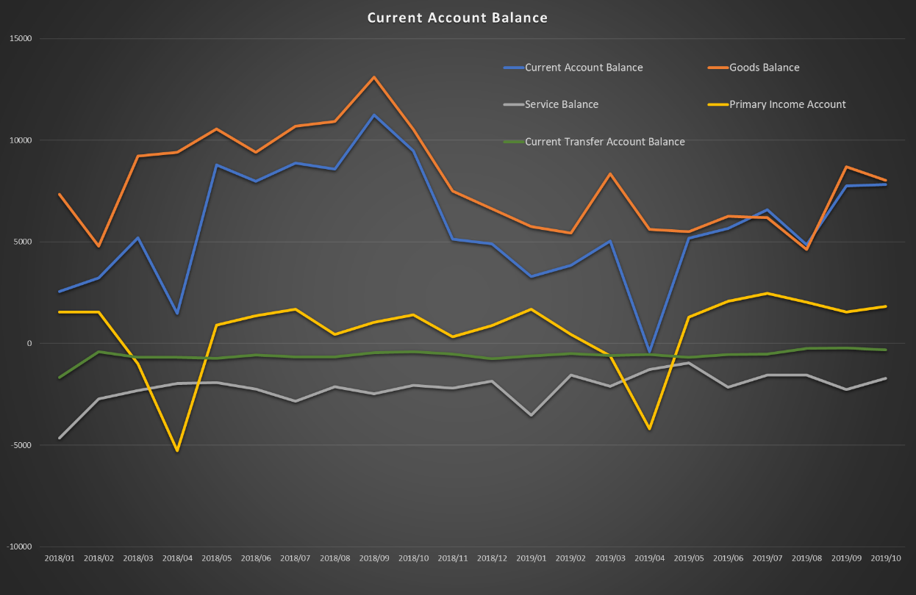 < current states of Current account Balance from January 2018. >

*Source : Bank of Korea :* [*http://ecos.bok.or.kr/*](http://ecos.bok.or.kr/)

Current account balance shows surplus. Excluding Service balance and Current Transfer Account Balance due to chronic loss, Current account balance and Goods Balance highly influence the Current account balance. U.S. and China Trade War and Japan Export Regulation induced decrease of both import and export. However, the change of import was larger than the change of export. Therefore, the current account balance was able to show surplus. We call this phenomenon “Recession Trade Surplus”. Danger of Recession Trade Surplus to Country that has high degree of dependence upon foreign trade is from decrease in export. No matter how much surplus was gained, decrease of export can cause serious damage to domestic market like shut down of export company. Also, exchange rate can influence the current account balance. As recession occur, the foreign investment decrease. Therefore, the exchange rate decrease. As a result, domestic product may have price competitiveness. Though, exchange rate in just one of the factors that influence current account balance. Foreign economic trend might have more serious impact on trade. Sometimes foreign political issue might have more powerful impact on current account balance. Therefore, due to these reasons, we need to carefully judge the situation and change the base interest rate. At last, freeze of base interest rate is the wisest decision that we can make in current states. Now, the bank of Korea just changed the base interest rate. Therefore, we need to see the impact of drop of base interest rate. After that we can see whether we should increase or decrease the interest rate additionally. Therefore, we decided to freeze the base interest rate.

1. Real estate

House price index (HPI) is one of the price indexes that measures the price changes of residential housing as a percentage change from some specific start date. We can distinguish HPI to two categories; Buying&Selling and Rent. Generally, people use house rent for living purpose. On the other hand, People use Buying&Selling as an investment to earn profits from the change of Market price of Real estates. Theoretically, drops of interest rate induces increase in demand of loan for investment. As a result, the amount of current money in housing market increase. At last, the price of house rises. Drop of interest rate not only induces increase of price, but also decrease of the housing price. Nowadays, people are educated from the experience. People know that cut down of base interest rate shows the deterioration of Macro economy. For this reason, people want to hold their cash in their deposit. Which means that demand of investment on housing decrease. Therefore, the price index of housing market decrease. Though, in real market, when the government decides to cut down the interest rate, the profitability of investment assets decrease. Therefore, people start to invest their money on housing market. As a result, the price of housing market increases. Below graph shows the HPI of Buying&Selling and Rent. As the bank of Korea started to decrease the base interest rate, the yellow graph, HPI of B&S, started to increase

< The HPI of Buying and Selling >

*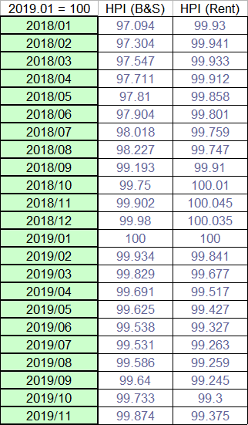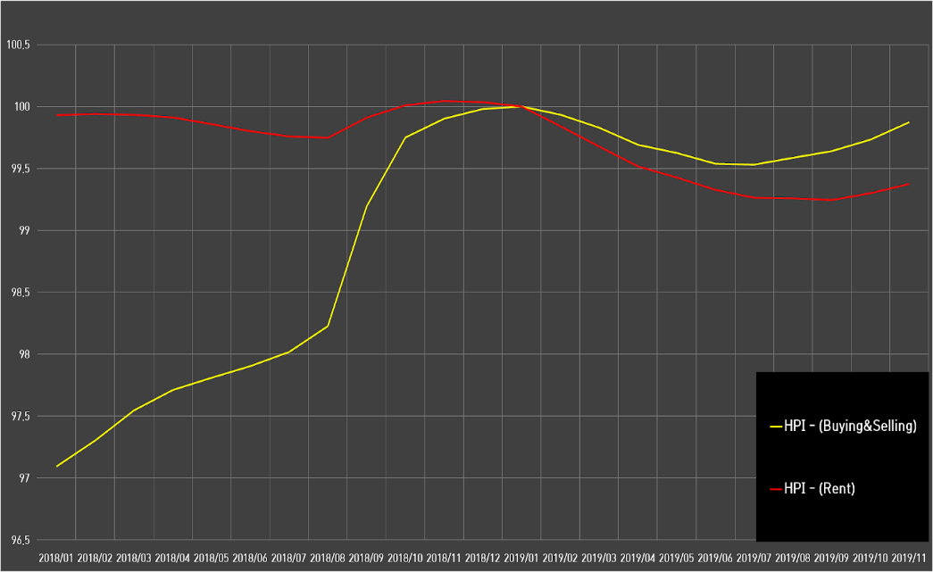Source : Bank of Korea*[*http://ecos.bok.or.kr/*](http://ecos.bok.or.kr/)

Decrease of interest rate induced rush phenomenon of investment in real estate market. In other word, people get money from the bank and make an investment in real estate. Consequently, the money supply of the Real estate market become active. Finally, the price of housing increase. Now, the market price of housing is much higher than the innate value of housing. As we compare this to subprime mortgage crisis, from 2000, U.S. housing price starts to increase. People thought that gain from selling house will be more profitable than paying interest because of loan. Therefore, people started to get money from the bank and invest on real estate market. Nevertheless, in 2007, the demand of housing started to decrease, and the price of house decreased. Then, people who invested on real estate market with loan was not be able to pay their debts. Since we already experienced and educated about the subprime mortgage phenomenon, it will not happen again in Korea. Also, the government of Korea regulated on House mortgage. It prevents house mortgage crisis. Nevertheless, similar shape of deflation might be occurred in real estate market. Therefore, we conclude that freeze in the base interest rate is best solution for present situation. Furthermore, the government should try different policies to solve the deflation problem.

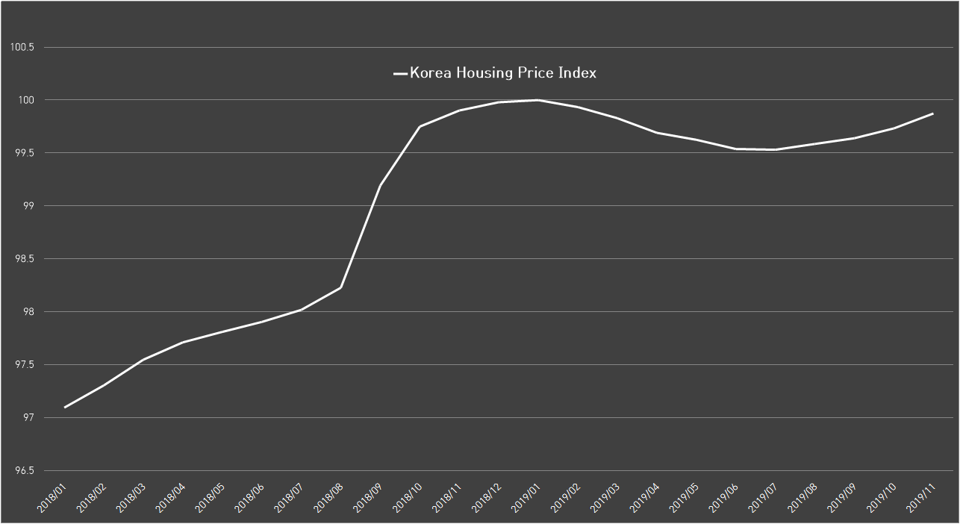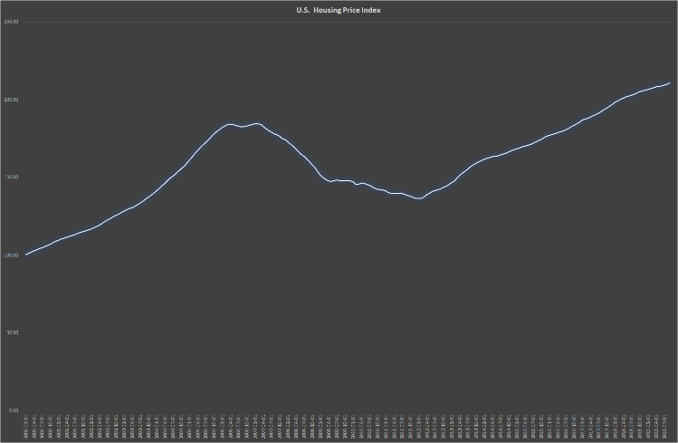<U.S Housing Price Index> <Korea Housing Price Index>

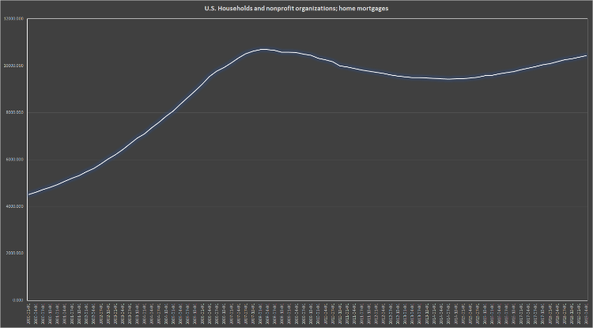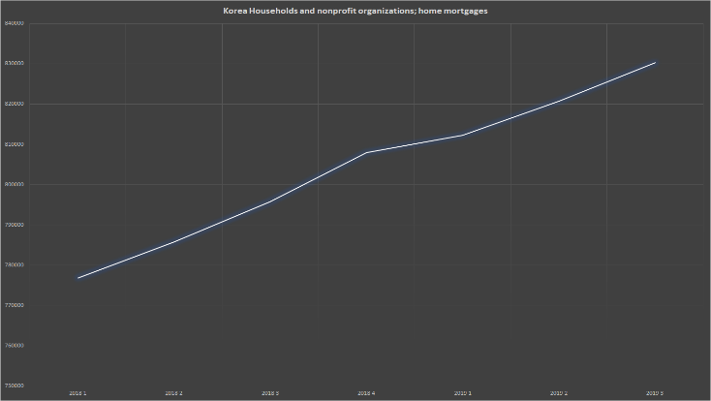<U.S Household and Nonprofit Organization House Mortgage> <Korea House Mortgage>

*Source :* [*https://fred.stlouisfed.org/series/CSUSHPISA*](https://fred.stlouisfed.org/series/CSUSHPISA)

*Source :* [*https://fred.stlouisfed.org/series/HMLBSHNO*](https://fred.stlouisfed.org/series/HMLBSHNO)

1. Market interes rate
2. Bond interest rate

The Korea government plans to issue more than 10 trillion won in treasury bonds from 2019 to 2023 due to the expansion of the extra budget or spending, accoding to the Ministry of Planning and Finance’s national fiscal management plan and the 2020 national budget plan.

< Planning and Performance of treasury bond issuance in November and December >

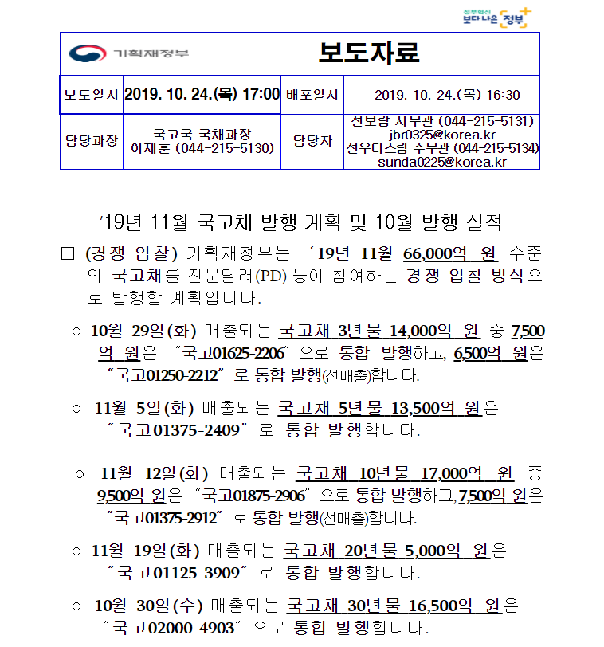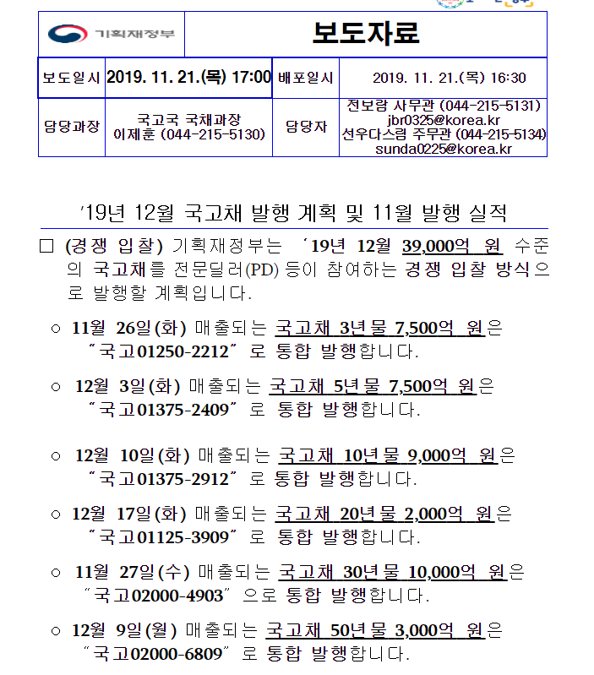

*Source : Ministry of Economy and Finance*

Market players, who expected a large amount of government bonds to be issued over 10 trillion won, sold bonds out of fear of falling prices, showing a trend of interest rate increases as the prices of bonds in the market fell.

< The daily trend of raising interest rates on Treasury bonds(2019.07.16~2019.11.22 >

**The treasury bond trate data from July 16 when the Bank of Korea began to lower its base interest rate.

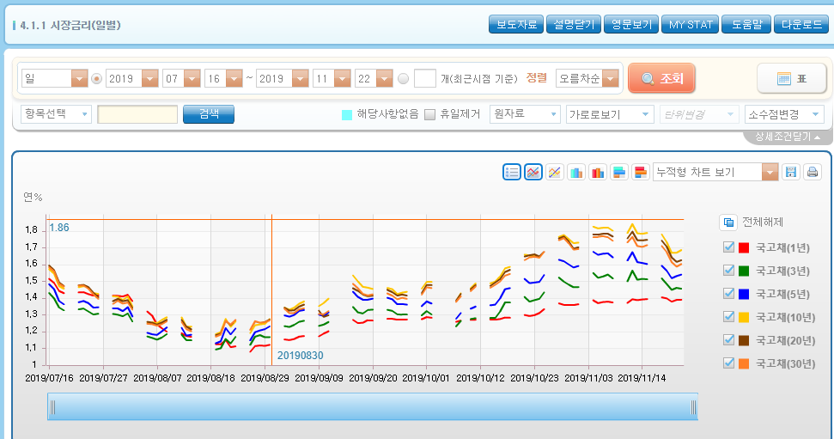

< The monthly trend of raising interest rates on Treasury bonds(2019.07~2019.11 >

*Source : Economics Statistics System*

The graph shows that the market interest rates for all types of treasury bonds, raging from one year to another for 50 years, tend to decline after the first base rate cut in July, but still rise despite further cuts in October from August. With the issuance of large amounts of bonds by the Government, the sale of bonds increases and the amount of money released on the market decreases, leaving some room for offsetting the effects of monetary policy. This means the economy is moving in a different direction than the Bank of Korea intended.

In addition, the governemnt’s bid for the ‘가평낙찰금리’ is higher than in October.

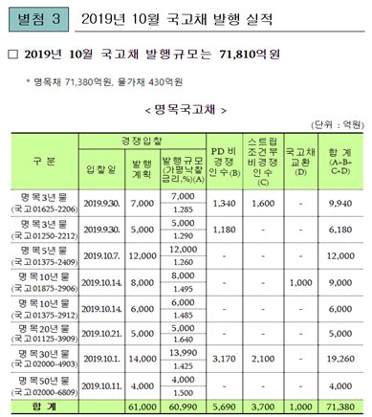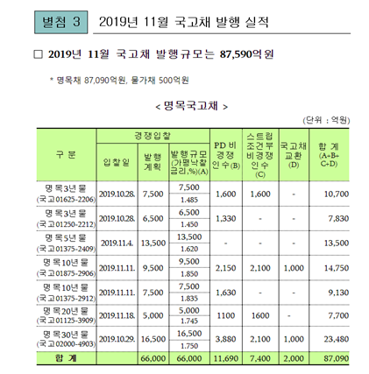

*Source : Ministry of Economy and Finance*

1. Bank loan interest rate

On April 18, 2018, the Financial Services Commision(FSC) announced regulations on deposit rates in earnest when it first introduced measures to introduce regulations on deposit rates in the savings bank sector, and in July 2018, it adjusted the amount of loans by increasing the weight of household loans by 15 percent and lowering the weight o corporate loans by 15 percent. Later on Nov. 4, Financial Supervisory Service(FSS) decided to regulate bank’s lending by additionally expanding regulations on mutual savings and banking supervision.

< Measures to regulate deposit rates of saving banks and regulations to supervise the banking industry >

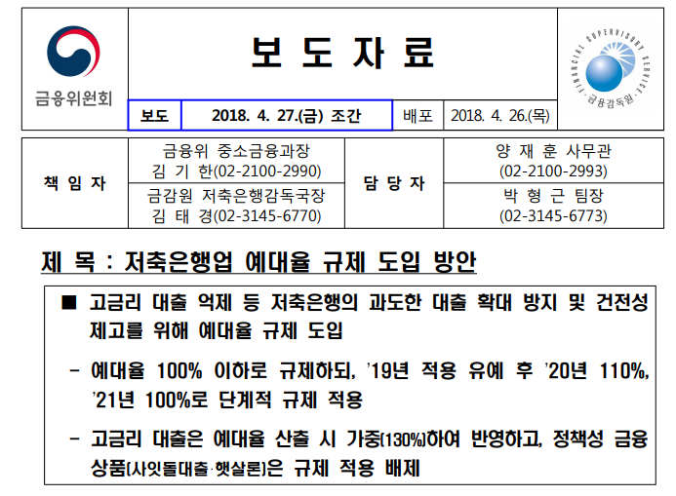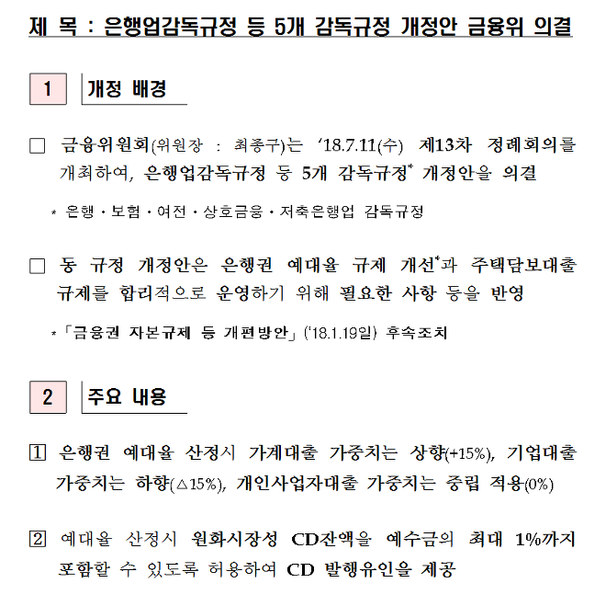

*Source : Financial Service Commission*

Loan-deposit ratio means a loan against a deposit, generally expressed as a percentage. An indicator of the extent of a bank’s asset composition or overrun, which is an important ratio in financial performance or bank management. Since banks need to prepare for payment by cash, deposit, etc. and second-line reserve by securities to meet the demand for payment of deposits, it is sound management policy to curb the deposit rate at around 80%. However Korea’s major banks’ Loan-deposit ratio encompasses 90 percent of those who are in the rear. Even Shinhan Bank has a ratio of more than 100%.

< Major banks’ Loan-deposit ratio in September >

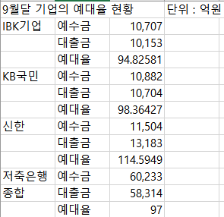

< Shinhan banks’ loan against deposit >

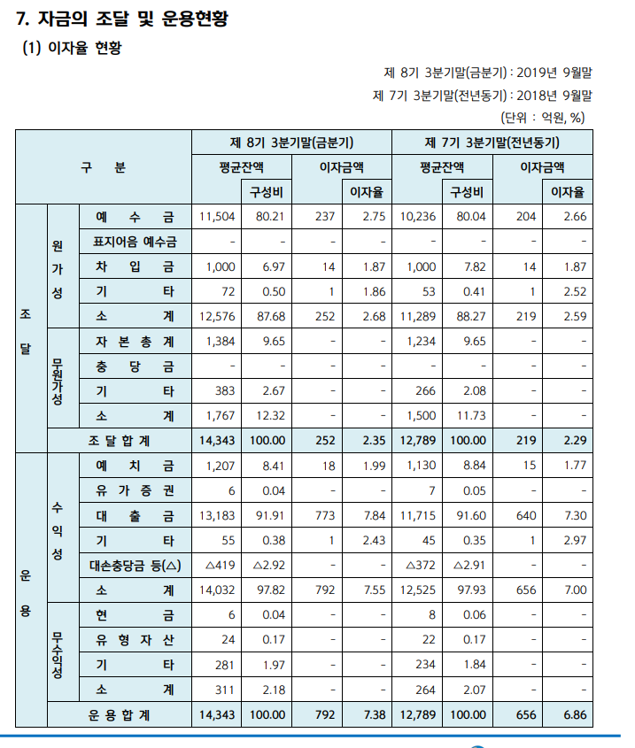

< KB bank’s loan against deposit >

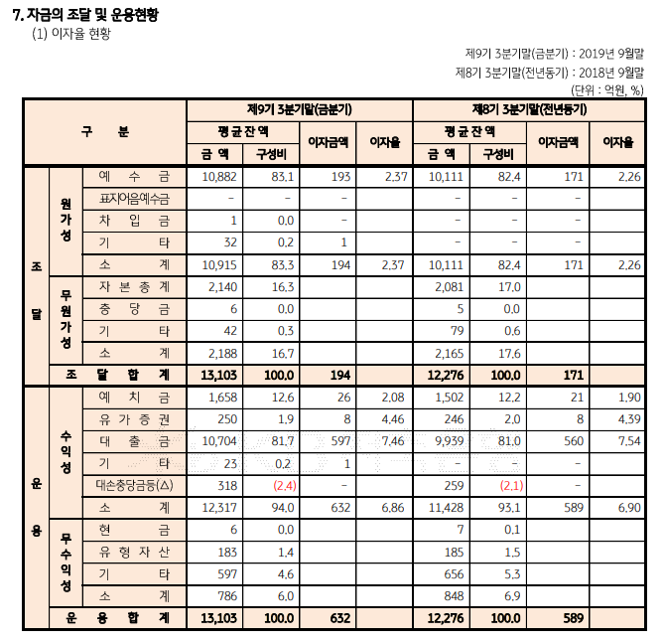

*Source : Korean Federation of Savings Bank*

As the government began to regulate the deposit rate in earnest in 2020 after the suspension in 2019, major banks began raising their loan rates with a policy of reducing lending. The following are the data on the general credit loan interest rates of major banks, which are mainly focused on ‘the average interest rate for non-working class’ financing, which is part of the low-interest products offered to low income households, and thus measures the extent of the general lending rate based on the average interest rate for the rest of them.

< General credit loan interest rate in September >

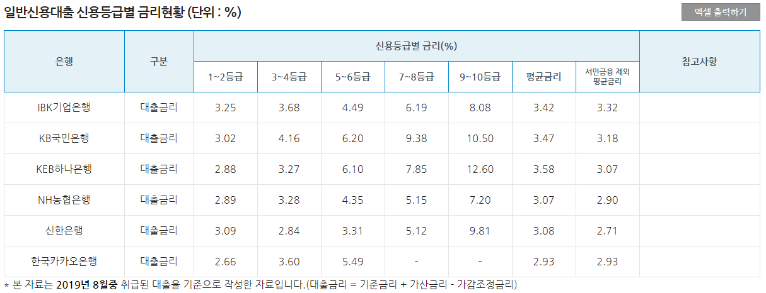

< General credit loan interest rate in September >

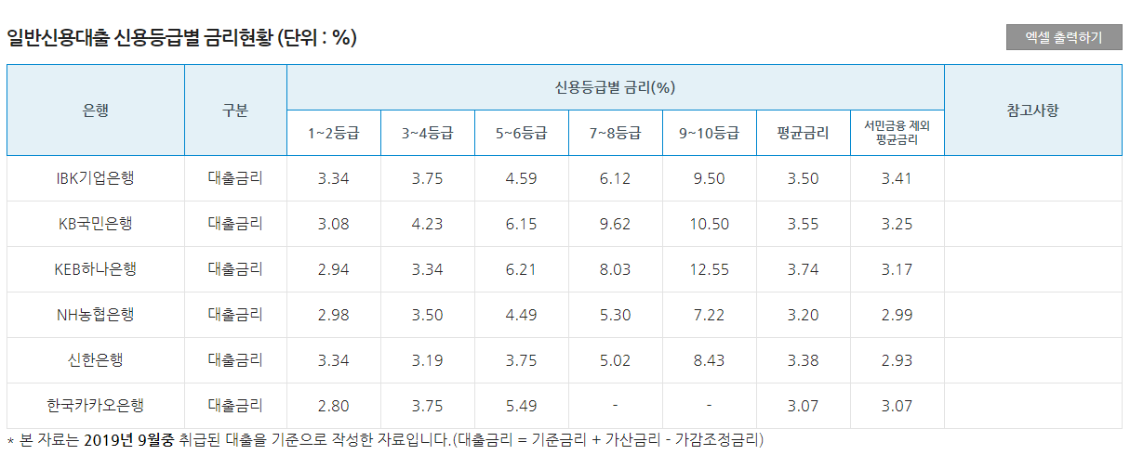

< General credit loan interest rate in September >

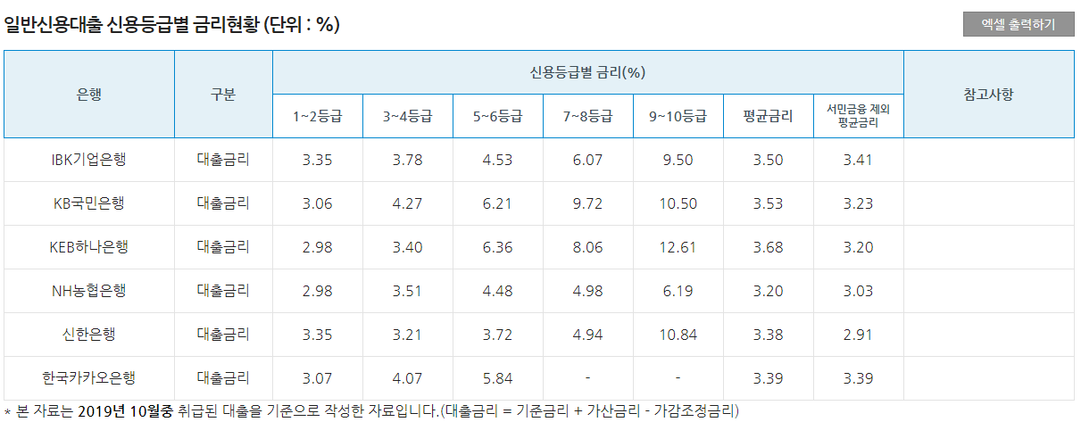

*Source : The Korean Federation of Banks*

To illustrate this graph, it is shown as follows.

Interest rates on mortgage loans on a installment basis also show an overall increase.

Although the Bank of Korea expected to boost lending and spur consumption and investment as a result by lowering the key interest rate, the effect has not been properly implemented in the market due to inconsistencies in various policy directions. Therefore, there is a need for the coordination of monetary policy and the management of fiscal policy in these various aspects of policy to be coordinated in a good direction.

IV. Conclusion

In conclusion, it is very difficult to predict the current economic situation because there are many variables such as trade conflicts between the U.S. and China and the resulting changes in exchange rates and export volume. As you can see, despite the rate cut, the impact on the local real economy is not being met by that intention. Consumption and production do not tend to increase one after another, prices do not rise due to expected inflation, which is concerned about low growth, and rather the possibility of a bubble in the real estate market as capital in other markets from continuing to lower interest rates have shifted entirely to the real estate market. In addition, inconsistencies in policy direction tend to offset the effect of the rate cut in bond and bank loan rate markets. Therefore, we should keep the base rate frozen rather than lower it further, look further at the impact of the October rate cut and keep an eye on the situation in the United States and China. It should also consider other policy measures such as quantitative easing other than interest rate adjustments.

<Reference>

[*http://kosis.kr/statHtml/statHtml.do?orgId=301&tblId=DT_040Y003&vw_cd=MT_ZTITLE&list_id=301_G&seqNo=&lang_mode=ko&language=kor&obj_var_id=&itm_id=&conn_path=MT_ZTITLE*](http://kosis.kr/statHtml/statHtml.do?orgId=301&tblId=DT_040Y003&vw_cd=MT_ZTITLE&list_id=301_G&seqNo=&lang_mode=ko&language=kor&obj_var_id=&itm_id=&conn_path=MT_ZTITLE) *(Expected inflation rate, CPI)*

[*https://www.hankyung.com/economy/article/2019102520381*](https://www.hankyung.com/economy/article/2019102520381) *(Low growth/ Low prices)*

[*https://fred.stlouisfed.org/series/CSUSHPISA*](https://fred.stlouisfed.org/series/CSUSHPISA) *(U.S Housing Price Index)*

[*https://fred.stlouisfed.org/series/HMLBSHNO*](https://fred.stlouisfed.org/series/HMLBSHNO) *( U.S Mortgage loan )*

[*http://ecos.bok.or.kr/*](http://ecos.bok.or.kr/) *( Korea Housing Sales Pre-text Price Index & Mortgage loan )*

[*http://www.bok.or.kr/portal/main/main.do*](http://www.bok.or.kr/portal/main/main.do) *( Korea’s base interest rate trend )*

[*http://www.moef.go.kr/nw/nes/detailNesDtaView.do;jsessionid=rJneBKeY1vbygIFKo0Z9BCjJ.node10?searchBbsId1=MOSFBBS_000000000028&searchNttId1=MOSF_000000000030374&menuNo=4010100*](http://www.moef.go.kr/nw/nes/detailNesDtaView.do;jsessionid=rJneBKeY1vbygIFKo0Z9BCjJ.node10?searchBbsId1=MOSFBBS_000000000028&searchNttId1=MOSF_000000000030374&menuNo=4010100) *( Planning to issue Treasury Bonds by the Ministry of Strategy and Finance in October )*

[*http://www.moef.go.kr/nw/nes/detailNesDtaView.do?searchBbsId=MOSFBBS_000000000028&menuNo=4010100&searchNttId=MOSF_000000000030736*](http://www.moef.go.kr/nw/nes/detailNesDtaView.do?searchBbsId=MOSFBBS_000000000028&menuNo=4010100&searchNttId=MOSF_000000000030736) *( Planning to issue Treasury Bonds by the Ministry of Strategy and Finance in November )*

[*https://www.moef.go.kr/nw/nes/detailNesDtaView.do?searchBbsId1=MOSFBBS_000000000028&searchNttId1=MOSF_000000000029635&menuNo=4010100*](https://www.moef.go.kr/nw/nes/detailNesDtaView.do?searchBbsId1=MOSFBBS_000000000028&searchNttId1=MOSF_000000000029635&menuNo=4010100) *( 2020 Budget Plan and 2019-2023 National Finance Management Plan)*

[*http://www.moef.go.kr/nw/nes/detailNesDtaView.do?menuNo=4010100&searchNttId1=MOSF_000000000030374&searchBbsId1=MOSFBBS_000000000028*](http://www.moef.go.kr/nw/nes/detailNesDtaView.do?menuNo=4010100&searchNttId1=MOSF_000000000030374&searchBbsId1=MOSFBBS_000000000028) *( Planning to issue Treasury Bonds in November, Bidding rate )*

[*http://www.moef.go.kr/nw/nes/detailNesDtaView.do?menuNo=4010100&searchNttId1=MOSF_000000000030736&searchBbsId1=MOSFBBS_000000000028*](http://www.moef.go.kr/nw/nes/detailNesDtaView.do?menuNo=4010100&searchNttId1=MOSF_000000000030736&searchBbsId1=MOSFBBS_000000000028) *( Planning to issue Treasury Bonds in December, Bidding rate )*

[*http://ecos.bok.or.kr/*](http://ecos.bok.or.kr/) *( Treasury bonds’ interest rates increasing trend )*

*file:///C:/Users/sec/Downloads/(180711)%20(%EB%B3%B4%EB%8F%84%EC%B0%B8%EA%B3%A0%EC%9E%90%EB%A3%8C)%20%EC%9D%80%ED%96%89%EC%97%85%EA%B0%90%EB%8F%85%EA%B7%9C%EC%A0%95%20%EB%93%B1%20%EA%B0%9C%EC%A0%95.pdf* *( Regulations on Banking Supervision – Financial Services Commission’s Regulation of Reserve rates’ )*

*file:///C:/Users/sec/Downloads/%EA%B8%88%EC%9C%B5%EC%9C%84%EC%9B%90%ED%9A%8C_%EC%A0%80%EC%B6%95%EC%9D%80%ED%96%89%EC%97%85%20%EC%98%88%EB%8C%80%EC%9C%A8%20%EA%B7%9C%EC%A0%9C%20%EB%8F%84%EC%9E%85%20%EB%B0%A9%EC%95%88_180426%20(6).pdf* *(Regulations on the Reserve Rate in the Savings Bank Industry – Financial Services Commission )*

*file:///C:/Users/sec/Downloads/191106%20(%EB%B3%B4%EB%8F%84%EC%9E%90%EB%A3%8C)%20%EC%83%81%ED%98%B8%EC%A0%80%EC%B6%95%EC%9D%80%ED%96%89%EC%97%85%EA%B0%90%EB%8F%85%EA%B7%9C%EC%A0%95%20%EA%B0%9C%EC%A0%95%EC%95%88%20%EA%B8%88%EC%9C%B5%EC%9C%84%20%EC%9D%98%EA%B2%B0.pdf* *( Regulations on Supervision o Mutual Savings Bank Industry – Financial Services Commission )*

[*https://portal.kfb.or.kr/compare/loan_household.php*](https://portal.kfb.or.kr/compare/loan_household.php) *( Mortgage laon interest rates by banks, general credit loan interest rates, data from The Korea Federation of Bank )*

[*https://www.fsb.or.kr/bank/statisticaldata_list.do*](https://www.fsb.or.kr/bank/statisticaldata_list.do) *( Total financial statements of savings banks, average deposit liabilities and loans, data from Korea Federation of Savings Bank )*

[*https://www.fsb.or.kr/bank/managenotice2.do*](https://www.fsb.or.kr/bank/managenotice2.do) *( Management disclosure by bank, Loan-deposit ratio, data from Korea Federation of Savings Bank)*

<https://www.hankyung.com/economy/article/2019120663697> *(declining public income)*

[*http://news.kmib.co.kr/article/view.asp?arcid=0014003335&code=61141111&cp=nv*](http://news.kmib.co.kr/article/view.asp?arcid=0014003335&code=61141111&cp=nv)*(declining public income)*

[*http://kosis.kr/index/index.do*](http://kosis.kr/index/index.do) *(declining public income)*

[*https://www.mk.co.kr/news/economy/view/2019/04/207115/*](https://www.mk.co.kr/news/economy/view/2019/04/207115/) *(US-China Trade War)*

[*https://news.kotra.or.kr/user/globalBbs/kotranews/3/globalBbsDataView.do?setIdx=242&dataIdx=176941*](https://news.kotra.or.kr/user/globalBbs/kotranews/3/globalBbsDataView.do?setIdx=242&dataIdx=176941) *(Hong Kong Protest)*

[*https://www.hankookilbo.com/News/Read/201908191298311822*](https://www.hankookilbo.com/News/Read/201908191298311822) *(Korea-Japan Trade War)*

[*http://www.keri.org/web/www/research_0201?p_p_id=EXT_BBS&p_p_lifecycle=0&p_p_state=normal&p_p_mode=view&p_p_col_id=column-1&p_p_col_count=1&_EXT_BBS_struts_action=%2Fext%2Fbbs%2Fview_message&_EXT_BBS_sCategory=&_EXT_BBS_sKeyType=&_EXT_BBS_sKeyword=&_EXT_BBS_curPage=1&_EXT_BBS_optKeyType1=&_EXT_BBS_optKeyType2=&_EXT_BBS_optKeyword1=&_EXT_BBS_optKeyword2=&_EXT_BBS_sLayoutId=0&_EXT_BBS_messageId=355751*](http://www.keri.org/web/www/research_0201?p_p_id=EXT_BBS&p_p_lifecycle=0&p_p_state=normal&p_p_mode=view&p_p_col_id=column-1&p_p_col_count=1&_EXT_BBS_struts_action=%2Fext%2Fbbs%2Fview_message&_EXT_BBS_sCategory=&_EXT_BBS_sKeyType=&_EXT_BBS_sKeyword=&_EXT_BBS_curPage=1&_EXT_BBS_optKeyType1=&_EXT_BBS_optKeyType2=&_EXT_BBS_optKeyword1=&_EXT_BBS_optKeyword2=&_EXT_BBS_sLayoutId=0&_EXT_BBS_messageId=355751) *(No-Deal Brexit)*

[*http://kosis.kr/index/index.do*](http://kosis.kr/index/index.do) *(GNI/GDI)*

[*http://ecos.bok.or.kr/*](http://ecos.bok.or.kr/) *(customer trend index)*

[*http://ecos.bok.or.kr/*](http://ecos.bok.or.kr/) *(Sales index by retail type)*